**FACTORIAL OF A GIVEN NUMBER**

**EXP NO: 9**

**AIM:** To find the factorial of a given number using 8085 microprocessor.

**ALGORITHM:**

1)    Load the data into register B  
  
2)    To start multiplication set D to 01H  
  
3)    Jump to step 7

4)   Decrements B to multiply previous number  
  
5)   Jump to step 3 till value of B>0  
  
6)  Take memory pointer to next location and store  
result  
  
7)    Load E with contents of B and clear accumulator  
  
8)    Repeatedly add contents of D to accumulator E times  
  
9)    Store accumulator content to D  
  
10) Go to step 4  
  
  
**PROGRAM:**

LDA 2001

MOV B,A

MVI C,01H

MVI E,01H

LOOP: MOV D,C

MVI A,00H

LP: ADD E

DCR D

JNZ LP

MOV E,A

INR C

DCR B

JNZ LOOP

MOV A,E

STA 2010

HLT  
  
   
  
  
**INPUT:**

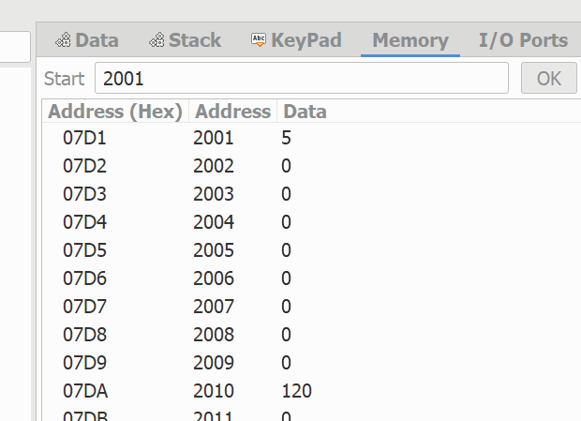  
  
  
   
  
  
**OUTPUT:**  
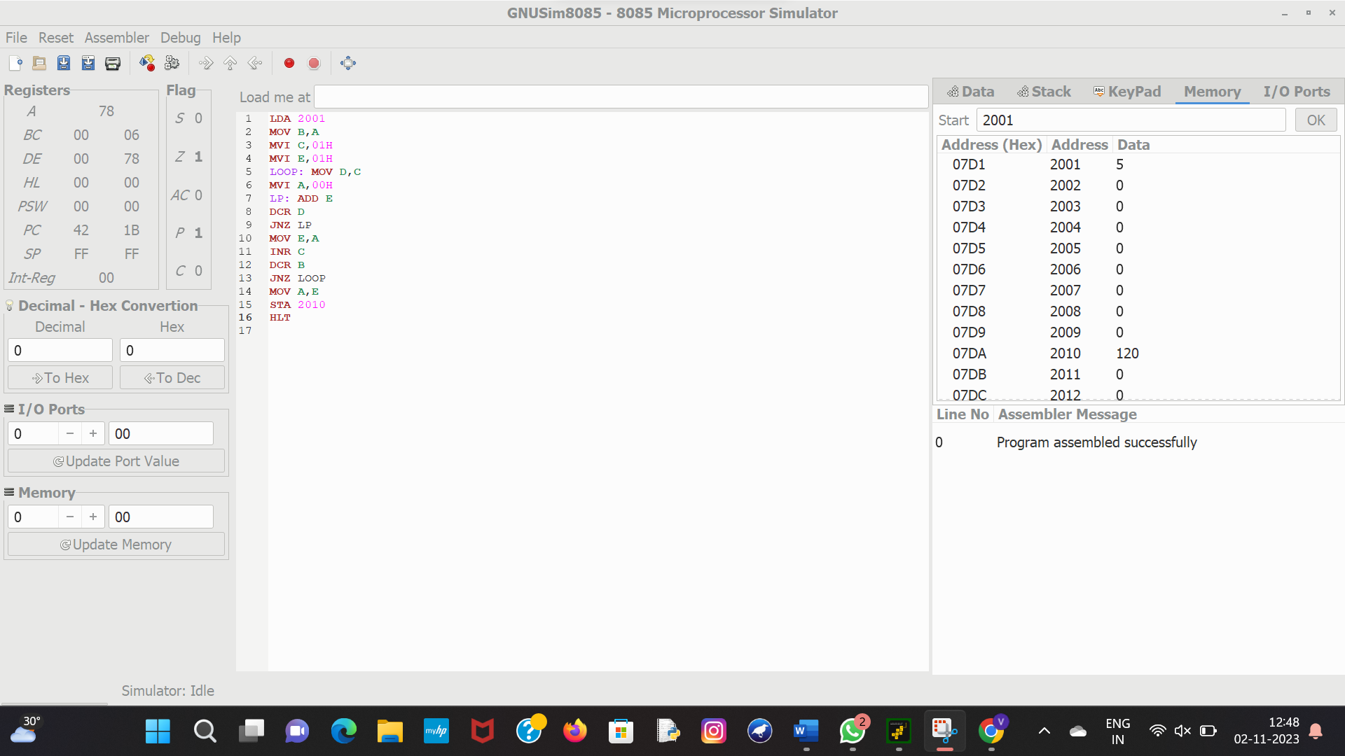  
  
  
  
**RESULT:**Thus the program was executed successfully using 8085  
processor simulator.